SPC DASHBOARD
CVD OXIDE THICKNESS PROCESS CONTROL
Simulation-Based Statistical Process Control Study
Prepared by: Tamoghna Patidar
B.Tech. Metallurgical and Materials Engineering — IIT Ropar
August 2026
Target: 100 nm | LSL: 95 nm | USL: 105 nm | 150 lots × 5 wafers

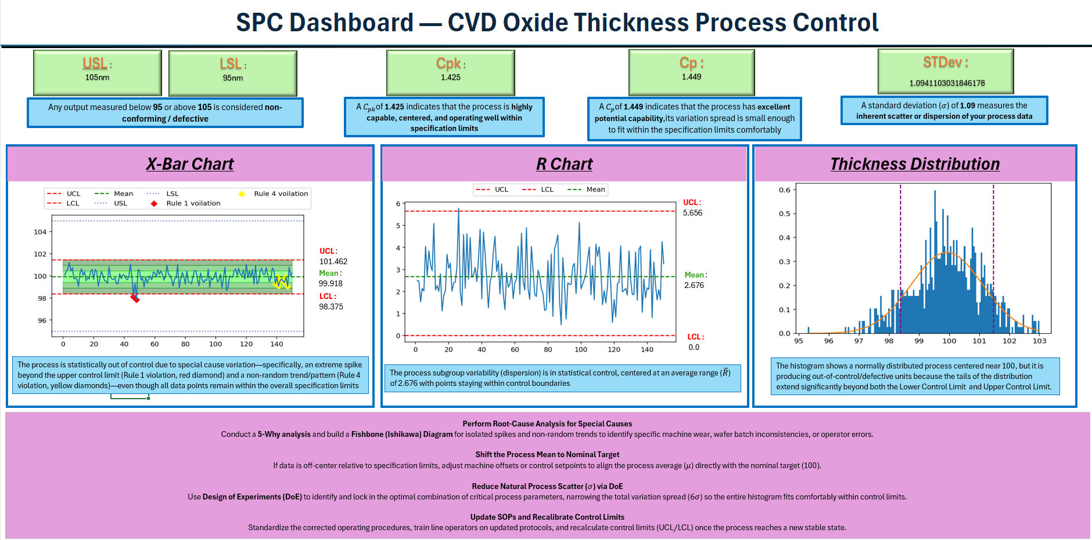

Executive Summary
This report presents a simulation-based Statistical Process Control (SPC) study for monitoring CVD oxide thickness in a semiconductor manufacturing context. Film thickness is treated as the critical quality characteristic because consistency in thin-film deposition is important for downstream fabrication operations.
The simulated process uses a target thickness of 100 nm with specification limits of 95–105 nm. The dataset contains 150 production lots with five wafer measurements per lot. The measurements are organized into rational subgroups and analyzed using X_bar-R control charts, selected Western Electric rules, and process capability indices Cp and Cpk.
Three operating conditions are investigated: normal/stable operation, a deliberate process mean shift, and increased process variation. The project follows an engineering workflow: establish a baseline, monitor the process, detect abnormal behavior, interpret the signal, hypothesize potential root causes, and recommend corrective action.
Note :All data are simulated. Results therefore demonstrate the methodology and engineering reasoning rather than representing measurements from an actual semiconductor fabrication facility.

1. Introduction

1.1 Background
Semiconductor manufacturing relies on tightly controlled process steps. Variation in deposition conditions, equipment state, material delivery, or measurement systems can affect thin-film properties and downstream process performance. CVD is widely used for thin-film deposition, making film thickness a useful quality characteristic for process monitoring.
SPC provides a systematic way to distinguish routine variation from evidence that a process has changed. This is particularly valuable when a process begins to drift before producing a large number of out-of-specification measurements.

1.2 Objectives
- Simulate wafer-level CVD oxide thickness measurements.
- Calculate lot-level subgroup means and ranges.
- Construct X_bar and R control charts.
- Apply selected Western Electric rules.
- Calculate Cp and Cpk.
- Compare stable, mean-shifted, and high-variation conditions.
- Translate statistical signals into engineering recommendations.

1.3 Scope and Assumptions
The project models the measurement output of a CVD deposition process rather than the physical CVD reaction. The baseline measurements are normally distributed with a nominal mean of 100 nm and standard deviation of 1.25 nm. Five wafers constitute one subgroup. Abnormal conditions are intentionally introduced to demonstrate SPC detection.

2. Process Description and Methodology

2.1 Process Representation
The modeled workflow represents CVD oxide deposition followed by wafer-thickness measurement. Each lot contains five measurements. The subgroup mean monitors process location, while the subgroup range monitors short-term within-lot variation.

2.2 Simulation Parameters
Parameter | Value
Target thickness | 100 nm
LSL | 95 nm
USL | 105 nm
Lots | 150
Wafers/lot | 5
Total measurements | 750
Baseline σ | 1.25 nm
Table 2.1. Base simulation parameters.

2.3 Subgroup and Control-Chart Calculations
For each lot, the five thickness measurements are used to calculate a subgroup mean and range. The grand mean and average range provide the baseline quantities for the X_bar and R charts.
X_bar UCL = X̄̄ + A₂R̄ | X_bar LCL = X̄̄ − A₂R̄
R UCL = D₄R̄ | R LCL = D₃R̄
For n = 5, the implementation uses A2 = 0.577, D3 = 0, D4 = 2.114 and d2 = 2.326.

2.4 Capability Analysis
Cp compares specification width with six process standard deviations, while Cpk also accounts for process centering. Capability should be interpreted together with control-chart evidence because capability indices do not by themselves prove statistical control.

2.5 Software and Workflow
Python, NumPy, Pandas, Matplotlib and SciPy are used for simulation, data handling, statistical calculations and visualization.
Manufacturing measurements → rational subgroups → X_bar/R monitoring → rule detection → capability analysis → engineering interpretation → corrective action.

3. Condition I — Normal / Stable Process

3.1 Condition Definition
Condition I establishes the baseline process. Measurements are generated around the 100 nm target without an intentionally introduced mean shift or increase in variation.

3.2 Distribution
The histogram is used to inspect the simulated thickness distribution and compare it with a fitted normal curve.
Standard deviation = 1.255
Figure 3.1
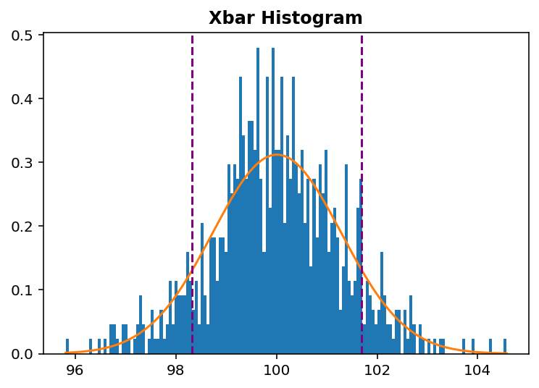

3.3 X_bar-R Control-Chart Analysis
The X_bar chart evaluates lot-to-lot changes in average thickness, while the R chart evaluates within-lot consistency.
X_bar = 100.009 Range Mean = 2.918
UCL = 101.693 UCL = 6.169
LCL = 98.326 LCL = 0
Figure 3.2a , Figure3.2b
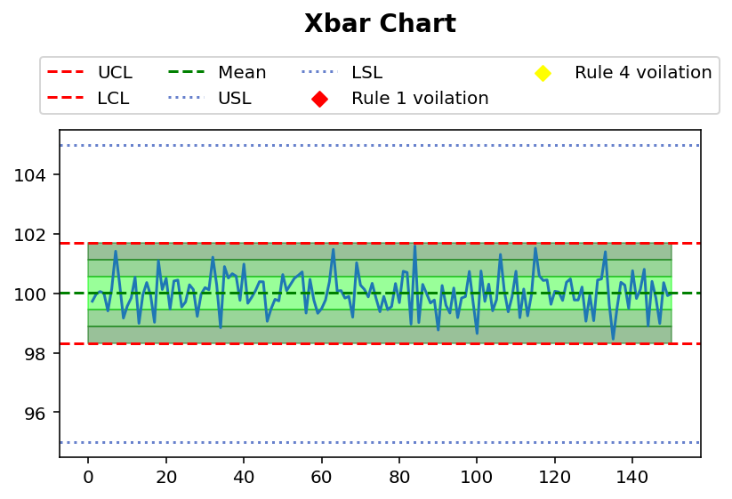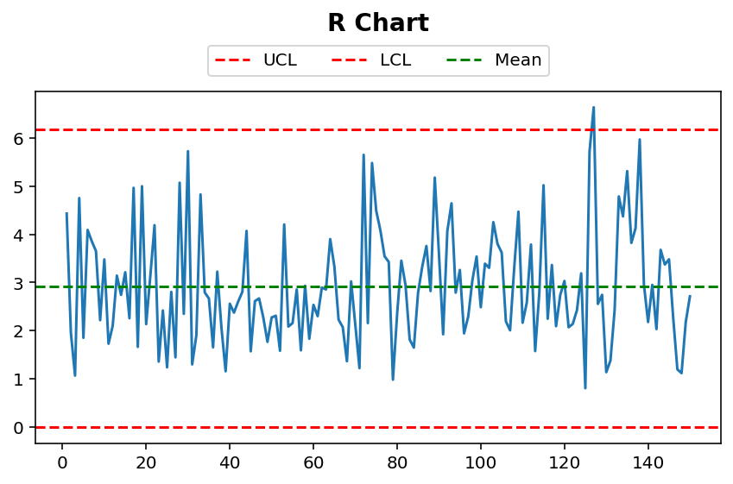
No voilation was detected in this case

3.4 Capability Analysis
The calculated Cp = 1.3284 indicates that the process variation is comfortably smaller than the available specification width of 10 nm. The Cpk = 1.3259 is very close to Cp, indicating that the process is also well centred within the specification limits.
The process mean is 100.009 nm, which is extremely close to the target of 100 nm. Therefore, there is practically no meaningful centre shift in Condition I. The small difference between Cp and Cpk also supports this observation.

3.5 Interpretation and Recommendations
The Condition I process is statistically capable and well centered relative to the 95–105 nm specification range. Continued monitoring is appropriate, with investigation initiated only when control-chart or pattern signals indicate a possible assignable cause.

4. Condition II — Process Mean Shift

4.1 Condition Definition
Condition II introduces a deliberate shift in process mean after an initially stable period. This represents a process-centering disturbance while keeping the basic within-lot variation approximately similar.
Distribution
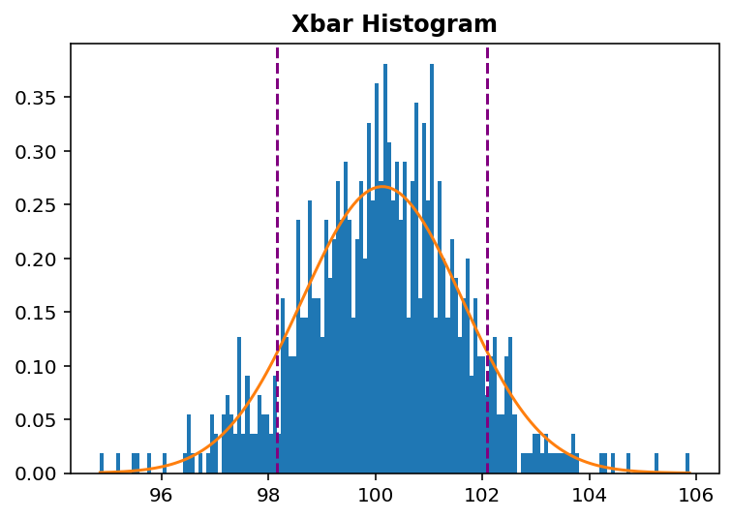

4.2 Control-Chart Analysis
The X_bar chart shows multiple shifts in process behavior, including negative shifts of 9, 13 and 21 consecutive points and positive shifts of 15 and 34 consecutive points from the center line. Rule 1 violations are also detected at Lots 57, 134, 137, 139, 140, 146 and 149, where subgroup means exceed the X_bar control limits. The R chart remains within its control limits, suggesting that the primary issue is a shift in process centering rather than a major increase in within-lot variation.
Output
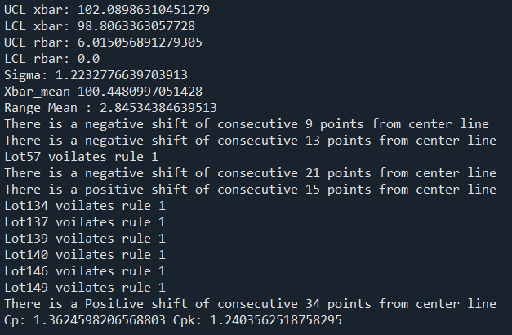
Figure 4.1a,Figure 4.1b
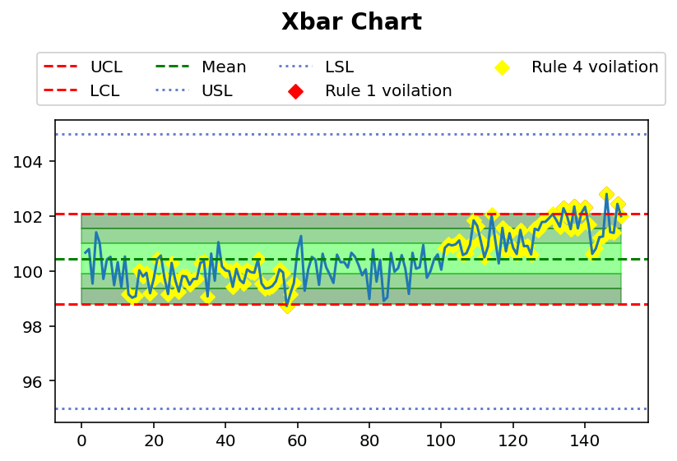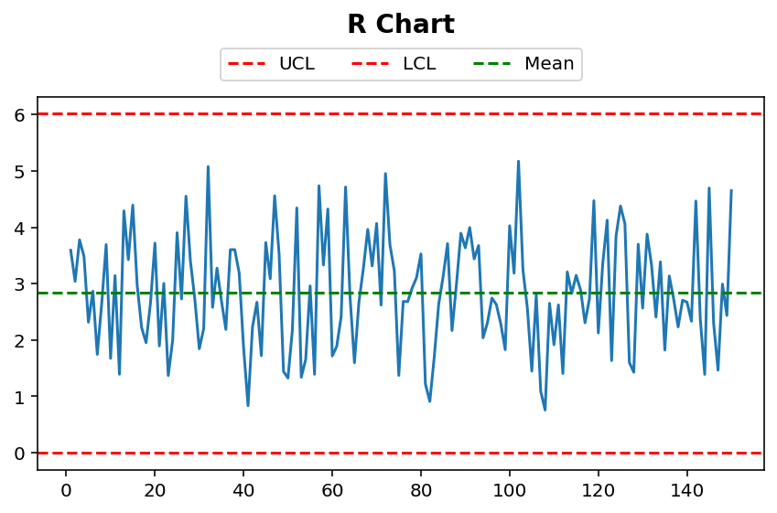

4.3 Capability Analysis
For Condition II, the process capability is:
- Cp = 1.3625
- Cpk = 1.2404
The Cp value indicates that the process variation is still reasonably small compared with the 95–105 nm specification width. However, the lower C_{pk} shows that the process is less well centred than Condition I. The upward shift in the process mean moves the process closer to the USL of 105 nm, reducing the effective capability. Thus, although the process may still be capable, its centring has deteriorated and corrective action is required.

4.4 Violations and Root-Cause Hypothesis
The analysis detected Rule 4 violations involving negative shifts of 9, 13 and 21 consecutive points and positive shifts of 15 and 34 consecutive points, along with Rule 1 violations at Lots 57, 134, 137, 139, 140, 146 and 149. These signals indicate sustained shifts rather than random variation.
Possible causes include changes in CVD chamber temperature, pressure, gas flow, deposition rate, equipment condition. These are hypotheses and should be verified using process and equipment history.

4.5 Recommendations
- Investigate process records around the detected shifts.
- Verify temperature, pressure and gas-flow conditions.
- Confirm the cause before recentering the process.
- Continue SPC monitoring after corrective action.
- After corrective action, continue SPC monitoring to confirm that the process returns toward the 100 nm target.

5. Condition III — Increased Process Variation

5.1 Condition Definition
Condition III introduces increased process variation while keeping the nominal process target approximately unchanged. It represents deterioration in process consistency rather than a simple shift in average thickness.
Distribution
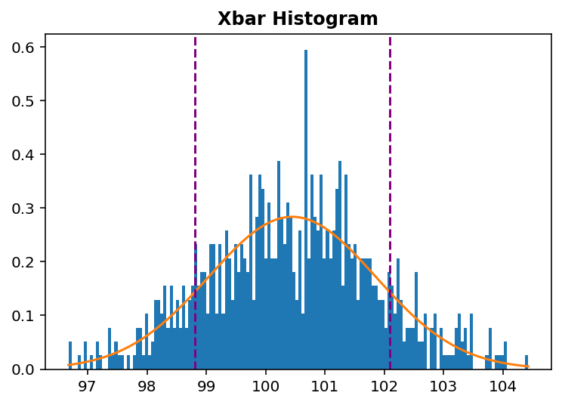

5.2 Control-Chart Analysis
The X_bar chart shows abnormal points in the later lots, including a Rule 1 violation at Lot 134. Rule 4 violations involving positive shifts of 8 and 10 consecutive points are also detected, indicating sustained shifts in process behavior. The R chart shows increased variation in the later lots, with multiple points exceeding the control limit. Overall, the process shows increased instability and variation compared with the normal condition.
Output
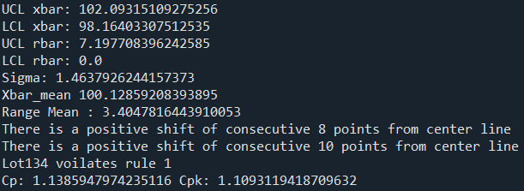
Figure 5.1a,b
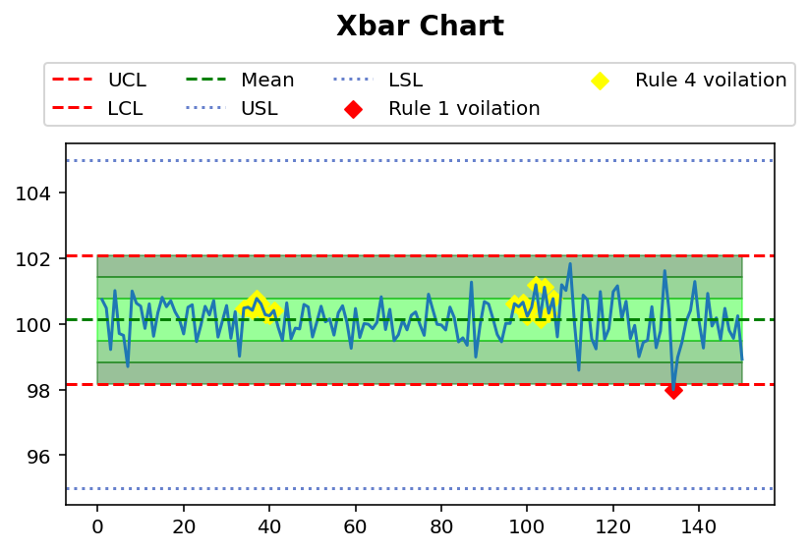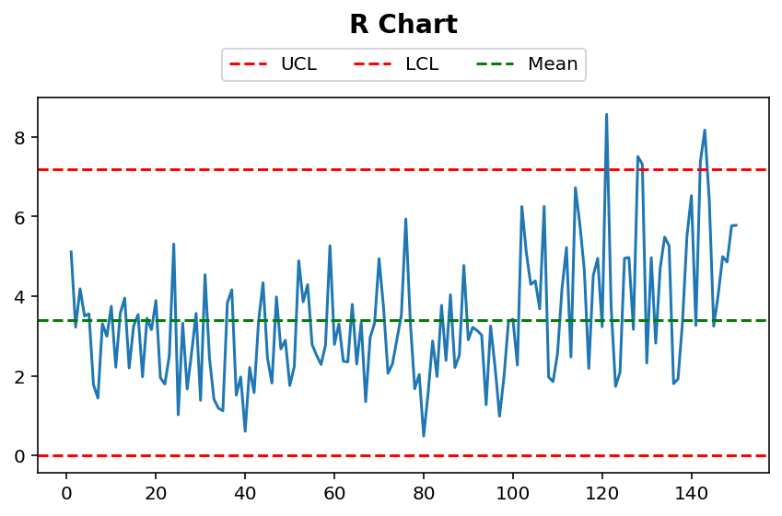

5.3 Capability Analysis
The calculated capability indices are:
- Cp = 1.1386
- Cpk = 1.1093
Compared with Condition I, both Cp and C_{pk} have decreased, indicating that the increased process variation has reduced capability. Although C_{pk} > 1 and the process remains marginally capable relative to the 95–105 nm specification, the lower capability indicates significantly less process margin and greater risk of producing non-conforming material.
The process mean is 100.1286 nm, which remains close to the 100 nm target. Therefore, the main deterioration is associated with increased process variation rather than a large mean shift.

5.4 Violations and Root-Cause Hypothesis
The analysis detected Rule 4 violations involving positive shifts of 8 and 10 consecutive points and a Rule 1 violation at Lot 134. The later-lot increase in R values further indicates deterioration in within-lot consistency.
Possible causes include CVD chamber instability, temperature or pressure fluctuations, unstable gas/precursor flow, chamber contamination, equipment degradation, or measurement-system variation.

5.5 Recommendations
- inspect chamber condition, contamination and maintenance history.
- Investigate the process changes in the later lots.
- Examine wafer-to-wafer and lot-to-lot sources of variation.
- Identify and remove the source of excess variation.
- Recalculate C_{p}/C_{pk} after corrective action to confirm recovery toward the Condition I baseline.

6. Comparative Analysis

6.1 Comparison of the Three Conditions
The three conditions demonstrate distinct process signatures. Condition I provides the stable baseline. Condition II primarily changes process location, while Condition III primarily changes process spread.
Metric | Normal | Mean Shift | Increased Variation
Mean | 100.009 | 100.448 | 100.129
σ | 1.255 | 1.223 | 1.464
X_bar violations | Null | Rule 1: Lots 57, 134, 137, 139, 140, 146, 149; Rule 4: 9-, 13-, 21-, 15- and 34-point runs | Rule 1: Lot 134; Rule 4: 8- and 10-point runs
R violations | Null | Null | Multiple later-lot violations
C_{p} | 1.328 | 1.362 | 1.139
C_{pk} | 1.326 | 1.240 | 1.109
Main signal | Stable | Location shift | Variation increase
Table 6.1. Comparative SPC and capability results.

6.2 Engineering Interpretation

The three conditions show different process behaviors. The Normal condition is stable and well centered around 100 nm. The Mean Shift condition shows a change in process centering, while the Increased Variation condition shows greater process variability with the mean still close to the target. Thus, SPC can help distinguish between a location problem and a variation problem.

6.3 Key Findings
- Normal condition shows the best process capability (Cp = 1.328, Cpk = 1.326).
- Mean Shift condition shows multiple shifts and reduced Cpk (1.240).
- Increased Variation condition has the lowest capability (Cp = 1.139, Cpk = 1.109).
- X_bar-chart violations identify changes in process centring.
- R-chart violations indicate increased within-lot variation.

7. Conclusion
This study demonstrates an SPC workflow for a simulated CVD oxide thickness process under three operating conditions. X_bar-R charts provide complementary information about process location and within-lot variation, while Western Electric rules add pattern-based detection. Cp and Cpk provide a separate measure of the relationship between process performance and engineering specifications.
The central process-engineering lesson is that SPC is not only a calculation of control limits. Its value lies in detecting abnormal behavior early and translating statistical evidence into a structured investigation and corrective-action process.

8. Future Scope
- Implement all Western Electric rules, including Zone A/B/C patterns.
- Add EWMA
- Build an automated SPC dashboard with alarms and violation summaries.
- Introduce multiple CVD process inputs and apply Design of Experiments.

